Data Publication Template

In this document, you will find the steps for setting up an account in DesignSafe and publishing your data and/or research instruments. Please check the boxes as you complete each section and add the requested information to the form below. Return this completed template to haz.research.awards@colorado.edu.

Step 1: Prepare your data, instrument, protocol, report, and/or other materials for upload to DesignSafe. Once you have the final, clean version of these materials, then you will proceed with the following steps.

- If you would like to view examples of materials that have been published previously by social scientists and interdisciplinary teams, please see the CONVERGE Data Ambassadors page at https://converge.colorado.edu/data/data-ambassadors/ and the list of the Natural Hazards Center’s Weather Ready Research data and instrument publications at https://hazards.colorado.edu/research/weather-ready/instrument-and-data-publication.

Step 2: Create an account or log into your existing account on DesignSafe at https://www.designsafe-ci.org/. Encourage all data co-authors to create an account as well.

Step 3: Click on the “Use DesignSafe” tab and the “Data Depot” button in the dropdown menu.

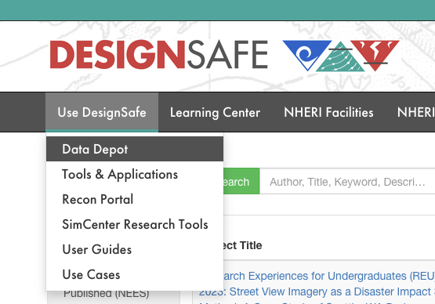

Step 4: Select “Add New Project”

Step 5: Add your project title.

- As good practice, your project title should be something that describes your project overall, not simply the same title as the dataset, instrument, or report that you are publishing. These materials should have their own specific names. Your project title should capture the project in a broad sense so that you can add additional research materials as the project expands.

Add Your Project Title Here:

Step 6: Identify the Principal Investigator (PI)

- The PI must have an account in DesignSafe. If you have collaborators who should be listed as co-PIs, they need to have an account with DesignSafe. You can also designate people with a DesignSafe account as “members”—people with this distinction can still work within the project but are not listed as PIs. You can also add unregistered members, who will be listed on the publication citation but are unable to edit the project.

Add PI Information Here:

Step 7: Edit the Project

- Once the project is created, you will begin editing. Go to the top, right-hand side of the screen and click the “Edit Project” link. A new page will appear where you can add more information. At the top, you will see your title of the project, which you can edit again here.

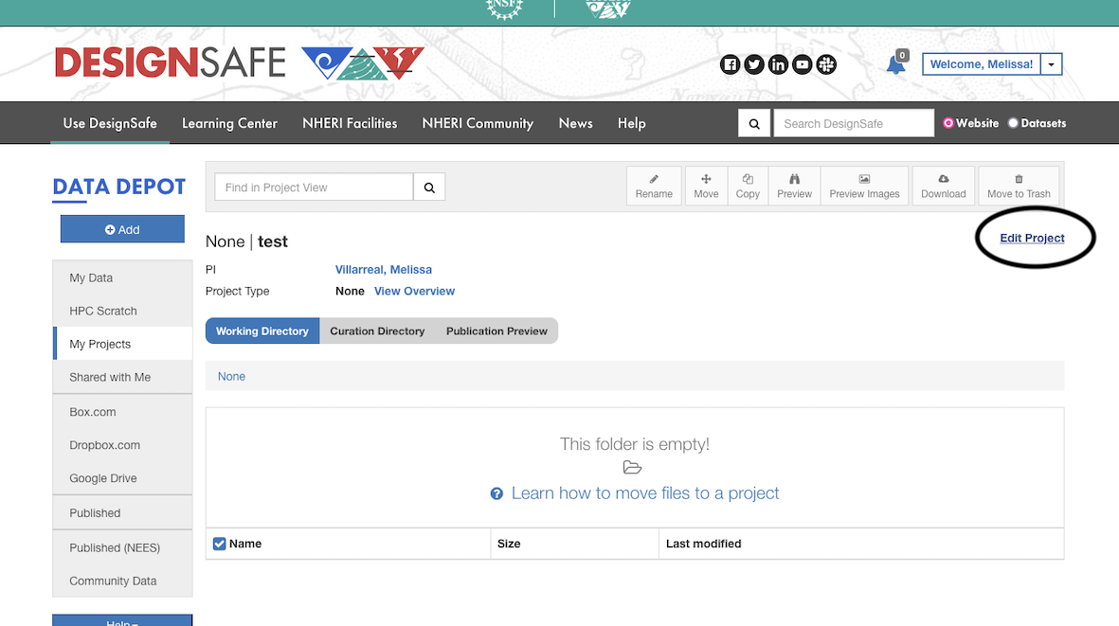

Step 8: Select the Project Type

- Click “Change Project Type.” DesignSafe will offer an overview of each Project Type. You can read these by clicking on a Project Type and clicking the Continue button. Read these carefully to select the most appropriate Project Type. Most social science researchers who have collected original data will likely select “Field Research Project.” Then you will have the option to enter the “Field Research Type.” In most cases for social science research, you will want to select “Social Science,” but “Field Experiment,” “Longitudinal Study,” and other options are available. Note that the rest of this guide assumes the project type of Field Research.

- If what you are attempting to publish does not involve Field Research, you may also want to select “Other.” This category is useful, for example, if you built a novel dataset. See here for one such example of an “Other” publication type of a dataset generated from publicly available websites.

Add Project Type Here:

Step 9: Select the Natural Hazard Types

- Next you will specify the hazard being researched (e.g., earthquake, flood) from a dropdown menu. If you are working with multiple hazards or in a general hazard context, you can click the “Other” option, then type in “Multiple Hazards.”

Step 10: Select the Data Type and Facilities

- Here you will review options from a dropdown menu where you will specify the nature or genre of the content. You will also be able to identify whether a specific facility or network, such as CONVERGE or SSEER, supported the effort. All Natural Hazards Center awardees should select “CONVERGE.”

Step 11: Add Award Funding Acknowledgement

- Natural Hazards Center awardees should review their award agreements for the appropriate grant # to insert.

Add Award Number(s) Here:

Step 12: Identify Published Referenced Data or Related Work

- This is an opportunity to link out to relevant websites, publications, or other materials relevant to your data or instrument publication.

Step 13: Identify the Specific Event studied, including location and start and end date, if relevant

Add Specific Event, if Applicable, Here:

Step 14: Enter Project Keywords

- Please see the CONVERGE Check Sheet focused on “Choosing Appropriate Research Keywords” for further guidance.

Add Project Keywords Here:

Step 15: Insert your Project Description

- The project description should be written in plain language that is accessible to a diverse audience of multidisciplinary researchers. The description should address these types of questions: What was this project about? What were your research goals or research questions? Why did you gather the data? Who or what did you study? How is this data or instrument unique? How can this data or instrument be reused? Who is the audience for this data or instrument? Please be as clear and descriptive as possible as this will help future users to understand more about your project! This should be about 750 words.

Add Project Description Here:

Step 16: Once you are finished editing the project, press the green “Update” button in the bottom right-hand corner.

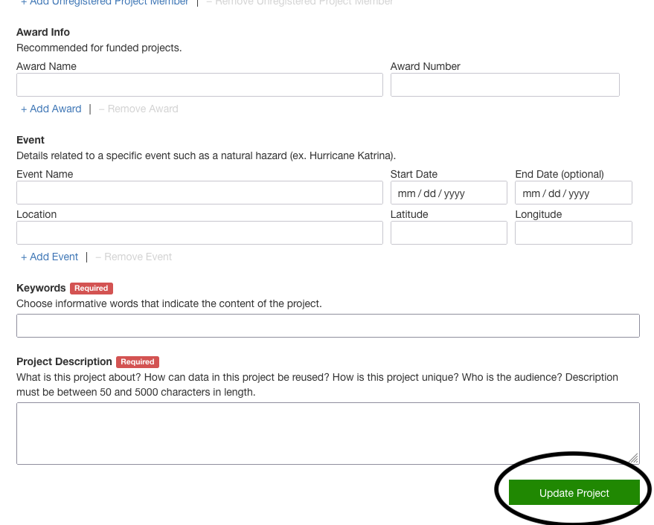

Step 17: Upload Files

- Click the blue “ADD” button in the top left corner of the screen and scroll down to “File Upload.” You can upload as many files as you need for your data publication (common file types include .csv, PDF, and readme files).

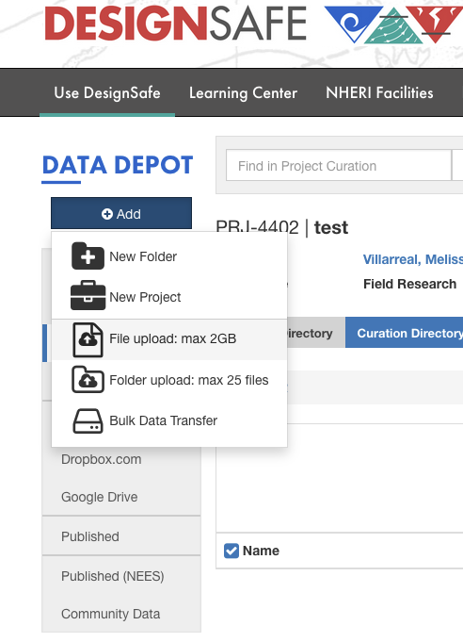

Step 18: Click on the Curation Directory and Relate Your Data

- Now you will click on the “Relate Data” link, next to the “Add Collections” link—which means linking and ordering your “Collections” under their corresponding “Missions.” You can do this by adding collections to missions and using the arrows to change the order or remove collections related to that mission. Your work will be saved automatically.

Step 19: Insert the Mission Title, Description, Location, Dates, and Authorship

- Start by clicking “Add Mission.” Enter the Mission Title. This title will appear, along with the project title, in your final publication with the permanent DOI. The mission title and description should be specific to the dataset you are publishing and therefore should be different than the overarching project description. Note that if you are conducting research with no specific site location, you can select Multiple Locations or enter N/A for the latitude and longitude.

Add Mission Title Here:

Add Mission Description Here:

- Once you are finished, press the green “Add Mission” button in the bottom right of the page.

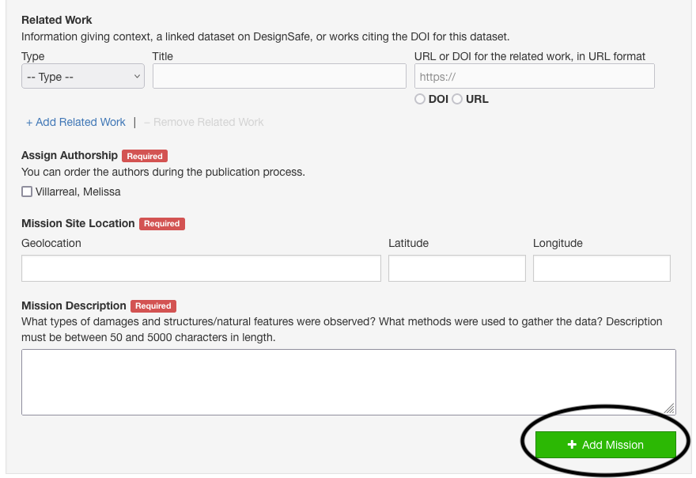

Step 20: Add Collections

- Click on the “Add Collections” link next to the “Add Missions” link. There are two types of collections that are important for social science research: “Research Planning Collections” and “Social Science Collections.” Research Planning Collections refer to planning of the project, such as IRB, research design, instruments, gathering data processes, among others. Social Sciences Collections are for those publishing datasets.

- Examples of collections that have been published as Research Planning Collections:

- Hoskova, B. J. Medzhitova, C. Colgan, B. Liang, and B. Lai. (2020). “Time 1 Interview Protocol on Colleges and COVID-19,” in Colleges and the COVID-19 Crisis. DesignSafe-CI. https://doi.org/10.17603/ds2-erzs-j690
- Villarreal, M. (2022) “Planning Documents for Semi-Structured Interviews with Service Providers,” in Documenting the Undocumented: How Mexican Immigrant Women Navigate Long-Term Post-Disaster Housing Recovery and Cumulative Disaster Impacts. DesignSafe-CI. https://doi.org/10.17603/ds2-rnz5-ek06
- Villarreal, M. (2022) “Planning Documents for Semi-Structured Interviews with Mexican Immigrant Women,” in Documenting the Undocumented: How Mexican Immigrant Women Navigate Long-Term Post-Disaster Housing Recovery and Cumulative Disaster Impacts. DesignSafe-CI. https://doi.org/10.17603/ds2-5bm1-y393

- Examples of collections that have been published as Social Science Collections:

- Adams, R., M. Mordy, and L. Peek. (2023). “Public Health Disaster Research Award Program Evaluation Survey Data,” in Public Health Disaster Research Award Program Evaluation. DesignSafe-CI. https://doi.org/10.17603/ds2-ana0-kf03

- Painter, M., M. Villarreal, and L. Peek. (2023). “2016-2021 State Hazard Mitigation Plans and Social Vulnerability.” in State Hazard Mitigation Plans and Social Vulnerability. DesignSafe-CI. https://doi.org/10.17603/ds2-sc34-as63

- Peek, L., H. Champeau, and J. Austin. (2023). “2022 Social Science Extreme Events Research (SSEER) Network,” in Social Science Extreme Events Research (SSEER) Network Data, Survey Instrument, and Annual Census. DesignSafe-CI. https://doi.org/10.17603/ds2-arw3-9z86

- Once selected, add a “Collection Title”—which should be unique to the collection—and “Date(s) of the Collection.” There are prompts available to assist with writing your Collection Description to ensure it is detailed, and you can also add additional optional information such as unit of analysis, modes of collection, sampling approaches and size, collection site location, and restrictions on using the data.

- You can also Data Collectors who were involved in collecting data for this research (if this is different from authorship). You can also select any “Equipment” used for gathering data.

- Once you are finished, hit the green “Add Collection” button in the bottom right-hand corner.

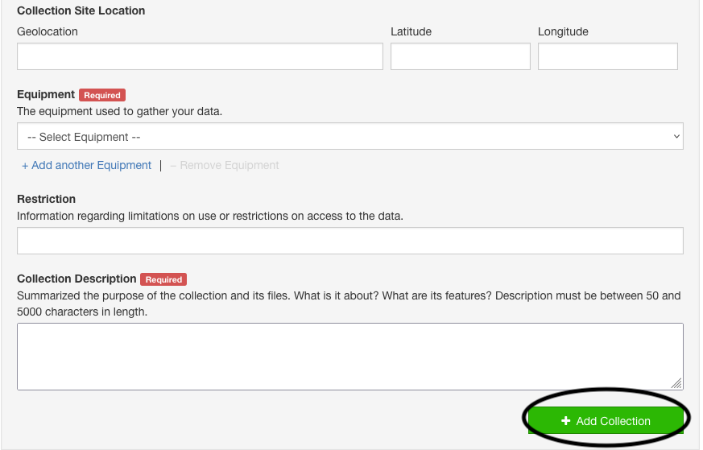

Step 21: Publication Preview

- Click on the blue “Publication Preview” preview button and then click on the “Publish/Amend/Version” green button to the right of the screen.

- This will take you through a series of final steps before data publication. You will hit “Continue,” and be taken to a page with options to Publish, Amend, or Version your data. At this point, you should only have a “Publish” option—click this button to start the publication process.

Step 22: Final Steps in the Publication Process
- Proofread your project for any errors.
- Proofread your mission for any errors.
- Proofread your collections for any errors.
- Confirm that the authors are listed in the correct order for publication; you can reorder authors at this stage.
- Finally, you will select a license for your data. Most will want to select “Open Data Commons Attribution,” which will allow others to freely share, reuse, and adapt your work. Users are expected to attribute to you any public use of your work (and you obtain copyright).

Step 23: Select the “Publish” button!

- It may take some time for the publication to go live, but you will receive a permanent DOI for your contribution. You should ensure that you list such publications on your CV and that you cite your data in subsequent publications.

Step 24: Congratulations! You are finished. Please return this completed template to haz.research.awards@colorado.edu.

