**DRU: Modeling Nuclear Disaster Risk**

**The Effects of Perceived Radiation Risk and Cumulative External Radiation Exposure to *Caesium-137* on Post-Chornobyl Psychosocial and Health Behavior Outcomes in Ukrainian Residents**

**RoseMarie Perez Foster, PhD., Natural Hazards Center, Univ. of Colorado**

**Robert Yaffee, PhD, New York University**

**INTRODUCTION**

The broad impact of the current study is to develop models of human nuclear disaster risk that will scientifically expand knowledge of complex psychosocial and health behavior consequences of radiological and other toxic disasters for the global community.

The cognitive perception of risk by communities exposed to toxic disasters (radiologic, chemical, biological), emerges as a strong predictor of long-term health, mental health, and psychosocial behavior outcomes in affected populations. However, the complex bio-psycho-social dynamics of this phenomenon are poorly understood, particularly in their critical relationship to empirically quantified levels of physical exposure to the source toxin.

In cooperation with ministries of the government of Ukraine, the current HSD supported study (2008-2011) conducts a random population sampling of 700 Ukrainian residents in 2 oblasts/ counties of Ukraine (Kiev, Zhitomyr). The study takes place approximately 25 years after this population was exposed to radionuclide fallout from the Chornobyl nuclear plant disaster in northern Ukraine (April 26, 1986). Long-term outcomes and predictive models of radiological disaster risk are sought to understand cognitive, health, mental health, and psychosocial factors in the exposed population. These factors are contextualized within the study protocol’s :

1.Dose reconstructions of cumulative external radiation particle exposure (caesium-137) for each study participant (n=700).

2. Assessment of perceptions of radiation health risk for each participant across time since the toxic event .

3. Construction of space-time maps of risk, where spatial epidemiology and spatial psychology are applied to mapping of perceived versus actual risk (reconstructed caesium-137 dose). Contours of CS-137 radiation dose will be compared to mapped patterns of health, mental health and behavioral outcomes. Maps of relative risk (ratio of logarithm of cases/controls) are to be formulated over several time waves. Particular interest lies in the dynamic interface between radiation dose exposure and health effects versus perceived radiation risk.

**Research Team and Cooperating Institutions**

The Investigator team spans the disciplines of radiation physics, risk analysis, medical and psychiatric epidemiology, and disaster sociology and psychology.

|  |  |
| --- | --- |
| **Cooperating Institutions**  National Science Foundation, DRU  University of Colorado, Boulder, Institute of Behavioral Science, Natural  Hazards Center    Colorado State University, Institute of Radiation and Health Physics  Ministry of Health of the Government of Ukraine  Academy of Labor and Social Relations, Ukraine  Vovici Corporation, USA | **Senior Personnel**  RoseMarie Perez Foster, PhD – Principal Investigator,  University of Colorado, Boulder, Institute of Behavioral Sciences, Natural Hazards Center  Thomas Borak, PhD – Co-Principal Investigator  Colorado State University, Institute of Radiation and Health Sciences  Kathleen Tierney, PhD – Co-Investigator  University of Colorado, Natural Hazards Center  Robert Yaffee, PhD – Senior Research Scientist/Statistician  New York University, Silver School of Social Work  Victor Chtenguelov, MD, PhD – Science Advisor, Ukraine  Ministry of the Government of Ukraine  Gleb Prib, MD, PhD – Project Director, Ukraine  Academy of Labor and Social Relations |

**Current Presentation**

The current poster reports on study progress thus far, including a pilot study of 100 cases, and a selected preliminary analysis of **281 experimental cases** where: current cumulative dose of radiation exposure to the Chornobyl incident source element (caesium 137), multiple dimensions of radiation risk perception, self reported health, geographical proximity to the Chornobyl event in 1986, and demographic features were factors of interest. Data for assessment of quantitative radiation dose reconstruction, cognitive risk perception, self-reported health was acquired for 3 time periods: Wave1-1986 (date of accident), Wave 2-1996, and Wave 3-current time. **Preliminary models were constructed and proposed herein to explain the sample’s perceived health risk from exposure to Chornobyl radiation.**

The pilot study was initiated in winter 2008. Formal data collection was begun in October 2009 and is still under way. Since this time an electronic survey instrument was designed and tested; the sampling frame was constructed; the viability of instruments and procedures were tested through the 100 pilot cases; dosimetric map data were acquired for caesium-137 deposition in Ukraine; methodology was designed for radiation dose reconstruction; and formal data collection of 281 respondents was initiated and analyzed with basic statistical procedures. The poster reports on sample description of these 281 respondents, radiation dose reconstruction procedures, data trends, preliminary model construction, and proposed statistical strategies that will be implemented upon completion of sampling at n=700.

**METHODOLOGY**

***Procedure:***

The studyconducts a stratified random sample of residents in the Kiev and Zhitomyr oblasts (states) of Ukraine. Six trained native interviewers administer a 1 ½ hr. Survey to consenting participants in their homes upon signature of informed consent. Participants are compensated $20 US equivalent. Survey is an electronic questionnaire mounted on interviewer hand-held computers. Upon questioning, survey response data is automatically entered, uploaded and maintained on a secured designated website that is managed by Vovici Corporation, USA.

***Participants/Sampling Procedure:***

Study participants in this sample are 30-84 years of age and have signed an informed consent. The stratified random sampling of Kiev and Zhitomyr Oblasts residents began in 2009 is still under way. Telephone numbers were randomly generated with a computer within each area code. The phone numbers were called with a maximum of four callbacks to obtain consent on the part of respondents to participate in the survey. Because the selected sample was stratified by area code, a random selection of phone numbers was performed within each area code, provided by a list from the telephone company. The total number of home telephones in the Kiev and Zhitomyr Oblasts at the beginning of our sampling period was tallied by the telephone company to be 1,637,389. This total was subdivided according to area code. With this information, we constructed sampling weights from the inversion of the probability of selection for each respondent. Although the large portion of the population has a home telephone, not everyone does. Some sampling bias can derive from poor, transient, and or homeless people not likely to have a home phone.

***Study Instruments:***

The **Survey Questionnaire** is comprised of several sections. It is an interactive electronic instrument that is accessed by interviewers in the field from hand-held computers. Survey sections include four standardized mental health and health behavior scales,[ Nottingham Health Profile , Brief Symptom Inventory-BSI , Mississippi Civilian PTSD Scale ]; medical ICD 10 diagnoses collected from the national Ukraine health registry, and questions that query demographics, perception of general and radiation risk, , radiation exposure information, sources of disaster-related information, life buffers, life stressors, major disruptive life experiences, economic and employment status and functioning, self-reported illnesses, multi-domain health behaviors, knowledge of the Chernobyl accident and scientific knowledge about the dynamics of radiation impact on health and environment. These queries are posed across time frames since the radiation disaster, with the goal of conducting both longitudinal panel assessments and survival analyses at the completion of data collection.

1. **Radiation Exposure Profile:** Following traditional international protocol for health physics and Chornobyl studies in particular (Likhtarev et al, 2002; 1996), the Survey queries factors that will render individual respondent reconstructions of cumulative external exposures to the specific radioactive source term: Caesium-137. These include the following data for formulaic dose reconstruction: all residential locations and lengths of stay since 1986, their geographical coordinates, residential dwelling construction features, dietary habits, food purchasing locations, and outdoor exposure by occupation.
2. **Nottingham Health Profile** This is a standardized mental health instrument used for assessment of perceived health problems. It has been extensively tested among divergent community groups in both research outcome and clinical contexts. The profile is designed to determine and quantify the severity of health symptoms (part 1) and health impact on multiple domains of functional behavior.(part 2). Face, content and criterion validity have been tested in various studies, showing the profile to be a reliable indicator of subjective health impact on physical, social and emotional domains of functioning(Hunt et al, 1985).
3. **Basic Symptom Inventory (BSI)** This is a tool for identifying self-reported clinically relevant psychological symptoms in adults. The BSI consists of 53 items that cover 9 symptom dimensions: somatization, obsession-compulsion, interpersonal sensitivity, depression, anxiety, hostility, phobic anxiety, paranoid ideation and psychoticism; as well as 3 global indices of mental health distress. Good internal consistency reliability for the 9 dimensions is reported by several studies (Derogatis, 1993; Aroian & Patsdaughter, 1989). The Inventory has also been successfully correlated with both the MMPI and the SCL-R-90 (Derogatis, 1993; Conoley & Kramer, 1989). Translated and revalidated by current Investigators on Russian-speaking sample in Ukraine, showing healthy internal consistency (alpha=.86) (Perez Foster, 2002; Perez Foster & Goldstein, 2007).
4. **Coping Strategy Indicator (CSI)** The CSI has been broadly tested in community samples yielding robust reliability and validity scores (Amirkhan, 1990; Amirkhan & Auyeung, 2007). The CSI consists of 33 items that test for 3 major strategies that characterize coping behavior: Problem Solving, Seeking Social Support, and Avoidance. Healthy internal consistency indicated in pilot study for current study.
5. **Civilian Mississippi PTSD Scale** A 30 item scale combining measurements of general distress and test items “anchored” to a specific traumatogenic event (Norris & Perilla, 1996).Demonstrates good internal consistency (alpha=.86) and adequate criterion validity when correlated with other measures. Translated and revalidated on a Russian-speaking sample showing good internal consistency (alpha=.88) (Perez Foster, 2002; Perez Foster & Goldstein, 2007).

***Quantitative/Statistical Procedures:***

**External Radiation Dose Reconstruction Procedure (Caesium-137)**

The European Commission and the IAEA has published the *Comprehensive Atlas of Caesium Deposition on Europe after the Chernobyl Accident* (1998). The *Atlas* contains detailed projection maps of deposition contours that are color coded based on Caesium (Cs) concentrations. The maps were available as vector graphics with multiple layers of information, including contour lines representing intervals of Cs deposition.  The maps were originally projected into an oblique azimuthal projection, but were converted into an equirectangular projection through a vector graphics package in order to facilitate data acquisition.  A very small number of points outside the Ukraine were acquired manually instead of automatically.  Caesium deposition for Asia was approximated using the deposition of easternmost Russia.

Grids of Latitude and Longitude were juxtaposed with the maps. Software was developed by current Investigators to recover the color (Cs concentration) at a specified Latitude and Longitude for each residence specified by a subject obtained from the Survey.

The effective dose, E, from external radiation exposure from radioactivity deposited on the ground is modeled in the following way:

1. Determine the dose rate in air based on the Cs deposition at the location as a function of time
2. Application of an age dependent factor that converts dose to air into effective whole body dose to the individual, Ka,i
3. Include modifying factors that include fraction of the time spent outdoors, fa,o and attenuation factors LH associated with occupancy fH in building and dwellings,



The results are presented as the cumulative reconstructed dose as a function of time following the accident. (see Appendix list of cumulative doses).

**Statistical Procedures**

The study is in its initial phases of data analysis, with complete data collection projected for mid 2011. The current preliminary analysis is based on a sampling of 281 respondents. Below are the full statistical procedures planned upon collection of the complete data set of 700 respondents:

* *Probability sampling of two Oblasts*

Random digit dialing household telephone survey

Stratification by raion

* *Multiple imputation after the data are collected*
* *Scale analysis*

Reliability analysis

* *Graphical exploratory data analysis*

Distributional analysis of endogenous variable

Dimension reduction techniques where needed

Identifying functional forms of relationships with endogenous

variables

Linear transformations where appropriate.

~~Transformation considerations such as the AVAS transformation~~

Nonlinear model consideration (intrinsically nonlinear relationships)

Semi-parametric model consideration (General Additive Models)

Regression splines + linear relationships

* *Methodological tournament*

Bivariate screening for variable selection

Data mining with effective degrees of freedom

General to specific modeling strategy(Hendry and Richard, 1982)

* *Mixed model repeated measures models*

Retrospective panel data analysis

Multilevel models for ecological analysis with empirical Bayesian adjustment

* *Path analysis to explore pathways of etiology in face of perceived and*

*actual risk*

Decomposing the total effects into robust direct, indirect, and

spurious effects

Exploring moderation, mediation, measurement error, latent variable,

simultaneity of pathways of etiology

* *Event history analysis of PTSD, Brief Symptom Inventory*
* *Accelerated failure time models* with gamma unobserved heterogeneity

model

* *A space-time map of relative risk*

Spatial epidemiology and spatial psychology are applied to map

perceived versus actual risk

Contours of CS 137 radiation dose reconstruction are compared to

patterns of PTSD, depression, anxiety, and other reported

symptomatology

Maps of relative risk (ratio of logarithm of cases/controls)

are formulated over several waves

Spatial autoregression models of perceived risk are used to test the

significance of relationships of distances from a nuclear accident

Levels of perceived risk are tested against type, severity, and psychological and somatic illness for spatial autocorrelation

Spatial-temporal models are developed with the aid of

Bayesian analysis with Markov-Chain Monte Carlo Estimation

Sensitivity analysis is applied to test robustness and reliability from

distributional variation of hypothesized prior distributions is

employed

**PRELIMINARY FINDINGS and DISCUSSION**

1. **Pilot Study:**

A random telephone pilot study of households was conducted in Autumn and Winter of 2008 and 2009. Phone numbers were randomly generated with Stata10 SE. After 100 respondents were collected, the pilot study was analyzed for basic information needed to plan the general survey. From the pilot study, we obtained a response rate based on the number of phones numbers generated to obtain the sample size needed. We determined the sample size needed by an a priori power and sample size analysis for each of the statistical techniques that we had proposed. For example, much of our analysis is to be performed with a variety of types of regression analysis. We estimated that we would need 397 respondents to detect a small-to-medium regression model effect size R2=0.055 using 21 explanatory variables with a power of 0.90 at a significance level of 0.05. Our objective is to obtain 700 respondents from the full survey. When we made an adjustment for the portion of the study that was not fully completed, we estimated that we would need 700 cases .

The Survey Questionnaire was constructed in both English and Russian language versions. Population focus groups were conducted for inquiry and review of cultural correctness of questions, and PI is an experienced researcher with populations from the former Soviet Union. Russian language translation of the 3 of the 4 standardized mental health/psychosocial scales was conducted with permission of original authors through the traditional translation/back translation technique. Reliabilities for all 4 scales were generated and found to be satisfactory for the current population of Russian-speaking respondents from Ukraine. From the pilot study, it was learned that exact dates should not be queried, but rather time ranges. We learned that recall was a problem when too much detail was asked regarding events that had occurred too long ago. Consequently, some questions were dropped and others refined. Pilot study findings were translated into the final Survey Questionnaire - an interactive electronic format, accessible to interviewers in the field through laptop software.

1. **Sampling of 281 Cases (current presentation):**

**Sample Description**

*Residential Geography:* The 281 participants were recruited by means of a random selection of household telephones in each oblast , stratified by area code (elaborated above). Four respondents were deleted from analysis due to being only ones from an area code. 44% are from the Kiev oblast and 56% from Zhitomyr. The sample emerged from the cities or towns of: Kiev, Zhitomyr, Berdichev, Boyarka, Barishevka, Korotich and Visheve.

*Gender:*  The sample at this point in time as it is being collected consists of 70.5% (198) women and 29.5% (83) men. This ratio holds for both Oblasts.

*Age distribution*: Respondents are 30 to 84 years old. The mean age is 52.7. The standard deviation is 13.3.

*Education:* This is a highly educated sample that is skewed towards technical and higher education, where well over 50% received education post high school. Approximately 39.5% received specialist or master’s degrees; and 38.08% received technical degrees. Four reported doctoral level degrees.

*Partnership/Family Status:* When we examine the marital status of the sample, most (68.5%) are married. About 14.5% report being widowed. 7.44% say that they are single. There are only about 4.96% who say that they are divorced with only 1.7% admitting to cohabiting. 3.31% say that they are separated. The family structure seems solidly intact.

*Family size:* The majority of families in our sample at this time (52.07%) have 2 children. 25.6% of the families report having one child. About 13% have no children. Large families are less common. All those who report having children so far claim that they have no more than four children.

*Employment Status:* 53.72% of our sample reports having a full-time job, while only 2.48% maintain that they work part time. Almost a third of our sample (31.4% indicate that they are retired. 11.57% say that they are unemployed.

*Occupational Status:* 12.4% of those in our sample report having a professional, executive, or managerial (administrative) position now. 7.44% maintain that they do technical, sales, or administrative support work. 3.31% report jobs in protective services or a service occupation. 14.05% are involved in homemaking or caregiving. Less than 2% admit to doing factory labor, machinist, transportation, or cleaning work. The same percent reports doing farming, fishing, forestry, trapping or logging. A large majority of females occupy the professional/executive positions as well as the homemaking kinds of work.

*Job Satisfaction: W*hen asked how happy in terms of percent they were with their job, we asked this question with respect to three waves: Wave 1: 1986. Wave 2: 1996, and Wave 3: now. The respondents revealed that a plurality reports being very happy with it now (100%). In Wave 2, almost half of the sample who responded, reported being 100% happy with it. In Wave 2 almost half of the sample (51%)reported being 100% happy with it now. However in Wave 1 around 1986: 65% reported being 100% happy with their job.

**Dose Reconstruction for Caesium-137**

Cumulative reconstructions of external exposure to Caesium-137 were performed for 3 “cumulative radiation time waves”: Wave 1-April 26, 1986-July, 1986; Wave 2-April 26, 1986-Jan 1, 1996; Wave 3- April 26, 1986-Jan. 1, 2010. The parameters for these cumulative radiation periods were established by previous Chornobyl studies The source of radiation responsible for external dose to study participants originates from radioactive fallout deposited on the ground following the Chornobyl accident. . There were no personal dosimeters available for individuals and thus estimates of the accumulated dose are obtained from a retrospective dose reconstruction process conducted by the current Investigators This cumulative dose is derived from locations of residency, dates at each location, time dependent 137Cs concentration in soil at each location, age dependent dose factors, type of dwelling and occupation. The distribution of reconstructed dose for 281 persons, in units of µGy, is shown in Fig. 1 and summarized in Table 1.

**Figure 1: Reconstructed cumulative dose for Caesium-137 in study sample**



**Table 1: Reconstructed cumulative dose for Caesium-137: Descriptive parameters**

|  |  |
| --- | --- |
| **Table 1** | |
|  | **µGy** |
| Minimum | 44 |
| Maximum | 26600 |
| Mode | 800 |
| Median | 715 |
| Mean | 838 |
| Standard Deviation | 1695 |
| Geometric Mean | 550 |
| Geometric Standard Deviation | 2.4 |

The graph and table show a very large range of accumulated doses that spans almost three orders of magnitude. The blue curve in Fig. 1 is a log normal distribution based on the geometric mean and standard deviation listed in Table 1. It should also be emphasized that all of the estimates of external dose for this sample of respondents are extremely small. It is impossible to identify any clinical or biophysical response of any kind for these doses. This is because the spontaneous rate for these biological effects exceeds any excess response that might be expected from this magnitude of external dose. In addition to this, there are other sources of external radiation that are responsible for much larger doses not related to fallout from the Chernobyl accident. Some estimates of these doses as well at statutory limits are shown in Table 2.

**Table 2: Statutory limits for other sources of external radiation:**

|  |  |  |
| --- | --- | --- |
| **Source** | **Annual rate (μGy/y)** | **20 year Cumulative**  **(μGy)** |
| Natural Radioactivity in soil | 200 | 40,000 |
| Cosmic Radiation | 300 | 60,000 |
| Regulatory limit for workers | 20,000 | 400,000 |
| Regulatory limit for general public | 1000 | 20,000 |
| Most probable value (mode) from dose reconstruction for first 281 respondents |  | 800 |

**Comparing Reconstructed Dose (actual risk) with Perception of Risk:**

In order to explore the nature of the relationship between physical reconstructed dose (actual dose) and the public perception of radiation risk, we graphically examined plots of bivariate relationships. Upon graphical observation of the nonlinear functional form of the relationship between the respondent’s self-reported health risk due to Chernobyl and the reconstructed cumulative external dose from radioactive fallout, the natural logarithm was applied to the cumulative dose to render the relationship more linear and amenable to analysis by linear model statistical methods. See Figure 2 for increases in cumulative dose by wave.

**Figure 2: Cumulative reconstructed dose for Caesium-137 by wave**

**C:\Users\ry\AppData\Local\Temp\jZip\jZip2F42\jZip6DF\CumdosewWave.emf**

**Figure 3: Perceived risk and reconstructed Caesium-137 dose**

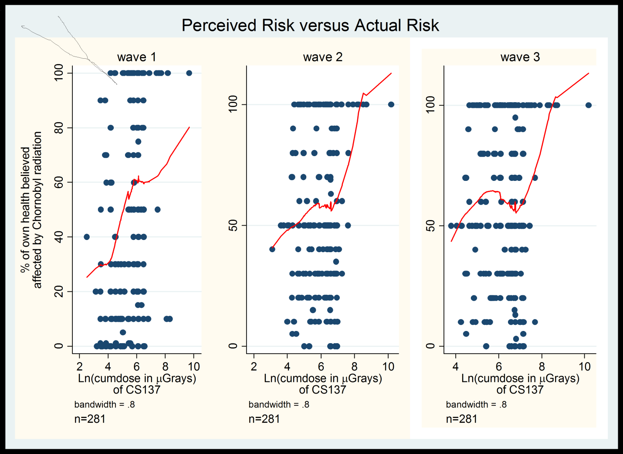

Despite the graphic congruence of perceived and actual risk factors, it is emphasized by the Investigators, that there is no radiological explanation for any association between the estimates of external dose from radioactive fallout and perceived risk. The magnitude of these doses is below any region where increases in biomedical effects could be differentiated from spontaneous incidence or those resulting from other natural sources of radiation.

However, Investigators conjecture that the self-reported perceived risk associated with radioactive fallout twenty years after the Chernobyl accident, may be influenced more by regionally-specific knowledge of radiation levels disseminated by media, public health and,or scientific reportage, than any direct effect from the radiation. This finding is of great interest and will be pursued in forthcoming analyses of regionally-specific sources of disaster-related information dissemination.

**Perception of Radiation Risk**

Uncertainty about the empirical risk from proximity to this disaster leads a large majority of the people to come away with a newly perceived radiation risk of adverse health effects to themselves and their family. From our preliminary review of the data we observe that more than three-fourths of the sample report that their health was adversely affected, as can be seen in the two frequencies listings immediately below. Approximately 86% of the respondents in our sample claim to know someone injured by the accident. These responses suggest that the impact has been made personal and something that these respondents will think about from as time goes by.

|  |  |  |  |
| --- | --- | --- | --- |
| **Were you injured because of Chornobyl accident in 1986?** | **Frequency** | **Percent** | **Cum** |
| * **No** | **90** | **32.03** | **32.03** |
| * **Yes** | **191** | **67.97** | **100.00** |
| **Total** | **281** | **100** |  |

|  |  |  |  |
| --- | --- | --- | --- |
| **Was anyone you knew injured by the Chornobyl accident in 1986** | **Frequency** | **Percent** | **Cum** |
| 1. **No** | **39** | **13.88** | **13.88** |
| 1. **Yes** | **242** | **86.12** | **100** |
| **Total** | **281** | **100** |  |

These tabulations reveal that the perception of risk to themselves and their family is personal and pronounced. How pervasive is this perceived risk to oneself, the family, and neighbors at three points in time--specifically, 1986, 1996, and in 2009-2010? One indicator of this is the average percent that a person believes his health has been affected by exposure to radiation in 1986, 1996, and in 2009-2010, shown below. As people possibly age across time, the average percent that people estimate their health to have been affected rises from 52.8% to

**Percent my health was affected by Chornobyl radiation:**

**Variable Obs Mean Std Dev Min Max**

**Wave 1 – 1986 265 52.79 38.08 0 100**

**Wave 2 - 1996 267 57.47 33.18 0 100**

**Wave 3 - 2010 268 60.09 34.20 0 100**

57.4% ten years later, to almost 60% approximately 14 years later. Time does not seem to be working in favor of alleviating the suffering of people whose history included inadvertent proximity to this toxic accident. **As time moves on, the average personal perception of radiation exposure grows – an interim finding of great interest, which runs counter to long-term disaster outcome research for non-toxic events.** Disaster-related anxiety typically shows decrease and attenuation over time. In addition, radiation-related concerns appear to be rather pervasive. Almost 61% of the Kiev and Zhitomyr respondents reported a belief that most human cancers diagnosed in their oblasts, developed from exposure to Chornobyl radiation.

Our preliminary findings also show that he belief in radiation health risk does not appear to be related to compromised mental health or aberrant psycho-social functioning, as denoted in Figure 4 which portrays the relationship between the BSI Global Severity Index (mental Health index), and perception of radiation risk.

**Figure 4: Population mental health index (BSI Global Severity Index) and self-perceived Chornobyl health risk**

C:\Users\ry\AppData\Local\Temp\jZip\jZip2F42\jZip6DF\BSIGlobseverByRadhlw.emf

These indicators provide **empirical indication of pervasive concern about the health effects of radiation exposure from the Chornobyl accident. To be emphasized is that this concern increases over time, and appears to be unrelated to compromised mental health such as broad spectrum anxiety, depressive, or psychotic disorders.**  This phenomenon must be more clearly understood for radiation and other toxic accidents. In the current study, only an empirical test of the reality of harmful radiation effects could determine whether the radiation risk perception in the sample population is or is not warranted. Thus far, our preliminary reconstruction of cumulative external Caesium dose from the accident, are below threshold levels for biomedical risk. **Our subsequent investigations will add** **reconstructed internal doses for Caesium-137** exposure for further exploration of the relationship between perceived and actual risk.

**Predictive Model Construction**

**1. Basic Linear Modeling Strategy: Understanding Perception of Health Risk from Chornobyl Radiation**

In this interim analysis, a set of linear models were constructed for the whole sample and gender-specific segments of the sample. We began with a full general model for each cohort segment, and then pruned each model for non-significant effects. This was done with the three sets of data, leaving us with six basic models. Nonsignificance was determined as anything with significance level higher than 0.10. This was decided as an appropriate cut-off level given that the residuals of the sample were frequently found to be non-normal based on the Shapiro-Wilk and Kolmogorov-Smirnov tests.

Upon completion, these models were subjected to *bootstrapped validation with cluster control,* as is demonstrated, because of space limitations, by the female model below. This operation allowed for control of the autocorrelation between Waves by employing a robust estimator that accounts for cluster correlation of observations between waves.

**Table 3: Perception of health risk from Chornobyl radiation: Bootstrapped validation with cluster control, trimmed female model**

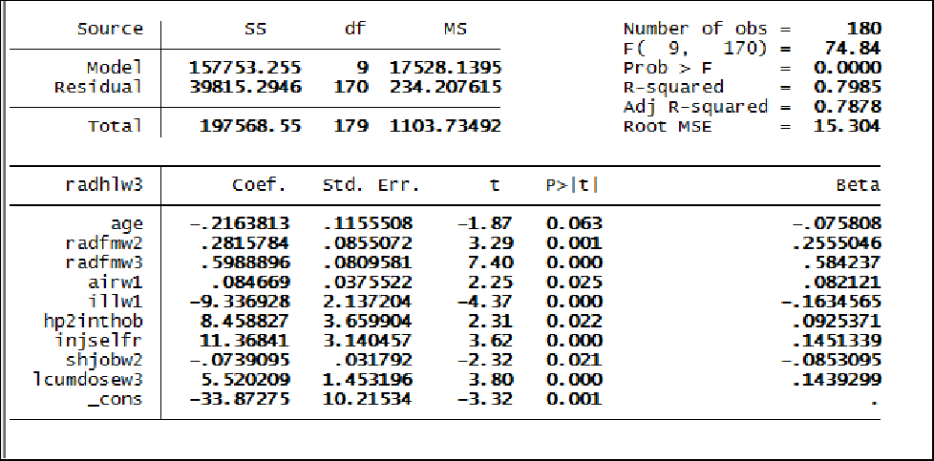

This bootstrap validation, which is a robust estimator accounting for cluster correlation of observations between Waves, matches its precursor models extremely well. We note that the goodness of fit is high at 0.799 and the adjusted fit also remains high at 0.788. The small difference between these two measures suggests that there is little excess baggage in terms of carrying ‘what counts’ in the fit of the model.

Thus the model explains that perception of health risk from Chornobyl in women is predicted by: someone who believes she has been injured in some way by the toxic event, believes that her family’s health has been affected, considered air and water pollution as hazardous to health in 1986, believes that her health compromises life interests and hobbies, and feels strained and hassled by her job. In addition, there is also a significant relationship between actual external dose exposure to Caesium-137, and perception of radiation risk; a finding of extreme interest that must be considered further, considering the low exposure dose and its probable non-clinical impact. However cognitive (media information about regional-specific fallout) and other factors, such as distance to the accident/raion must be considered.

1. Multilevel Mixed Effects Model with Spatial and Temporal Parameters of Population Perception of Chornobyl Health Risk

After excluding endogenous variables from the information set of the model, a multilevel mixed effects regression model is fit to explain respondent perceived Chornobyl health risk over space and time. We test whether 2 wds deleted environmental or societal phenomena are associated with self-perceived Chornobyl health risk (radhlw). We are looking for evidence relating a sense of perceived distance of the residence, workplace, or general location of the respondent to the accident site.

To render the natural log of cumulative external 137CS dose linear and amenable to analysis, we apply a simple natural log transformation to it. We use the nesting for the multilevel mixed effect regression equations to test distance related effects of a contextual type. The raion means of these variables provide expected contextual or environmental impacts on the intercepts and slopes of our model. In addition to finding significant effects on the level ~~intercept~~ and/or rate of change of the model, we could use hierarchical models potentially with cross-level interactions to test and analyze contextual effects.

From Table 4, we observe significant macro-level environmental associations with the amount of air and water polluted by Chornobyl and the natural log of cumulative external dose of 137Caesium**. Among the significant macro-level effects we note the natural log of cumulative reconstructed external dose of 137CS absorbed by the respondent, along with the amount of air and water believed to have been polluted by Chornobyl. The effects of age, gender, external dose of 137CS, any injury the respondent reports that he or she suffered as a result of Chornobyl and the interference with his or her interests and hobbies on account of this tragedy, emerge as significant.** The growth rate of self-perceived Chornobyl health risk is significant from wave one to wave two, but levels off into nonsignificance after wave three begins. The net effect over time is therefore best estimated by a linear growth trend over the 24 year period of less than a 10 percentage point increase. If we formulate the relationship as a regression line, shown below, the intercept of the vertical axis, α, begins at

**radhlw itk = α itk + β wave itk + (other fixed effects that need to be controlled) + e itk**

about 52 percent, but does not exceed 60% for 24 years. Whether or not, β, the slope coefficient for wave, is statistically significant, we retain that as a temporal reference for the rate of change to keep track of the magnitude of the rate of change. To track the trajectory of change for an individual, we examine the within-subject effect of nesting time within subject among the residuals from our level one model. After observing a high first order residual autocorrelation of slightly more than 0.70, we apply an autocorrelation structure to help control for the bias that this condition might engender. By using equation two as basis for a first order time trend for our subjects, we are able to nest both fixed and random effects on the individual into the raion in which he works and resides. From our raion centered covariates we avoid the need for an intercept that could have collinearity with the random i~~/~~ntercept and/or the random slope as much as possible. If we perform this analysis for each raion, we get a raion-specific regression equation, which provides the data for a between-raion analysis. Thus, we can observe what variation exists among raions.

The upper panel of Table 4 reveals the nesting structure of the panels in the multilevel model. The spatial autocorrelation clustering comprises 22 raions within which reside 266 respondents who answered all questions used to build the model. It also indicates the number of units of analysis within each cluster. The nesting order of the model proceeds upward in the table.

The repeated waves in the temporal dimension are accommodated by the ar (1) error covariance structure. Table 4 reveals in the upper panel, the level structure of the model. There are 22 raions within which are nested 266 persons with complete answers on all variables included within the model.

In the second panel, the fixed effects (X’B), which define the mean structure of the marginal model, are listed. The overall significance is tested with a multivariate Wald test above the second panel on the right. The output can be interpreted as a standard regression output, with statistical significance of the individual parameters indicated by the p-values. When the fixed effects are graphed against the waves, there is a slight but non- significant increase in slope throughout the study, shown in Figure 5.

In the third panel, the random effects are displayed in a subpanel for each layer. The clustering variable is listed in the upper left. At each level, the random intercept is called the constant. This represents the average level or the random intercept at that level. Below the layer panels is the model residual.

When covariates are listed at that level they are interacting with the clustering variable at that level to impact the self-perceived Chornobyl health risk. When the residual structure at the upper levels is identity, the variables are organized in block diagonal form so they would be independent of one another. When covariates are listed within these levels, they are random effects of the parameters. With repeated measures, there is considerable autocorrelation from one wave to the other, the bias for which is attenuated by the fitting of a first-order autoregression process for the residuals.

Table 4: Multilevel Mixed Effects Regressions with Temporal and Spatial Dimensions – 3 Waves



1. **Empirical Bayes Optimization of “Best Linear Unbiased Predictor” of Population Perception of Chornobyl Health Risk**

However, we use the intraclass correlation coefficient as a reliability coefficient with which to tune our estimate/prediction. Let the intraclasss correlation, the proportion of the variance explained (between subjects variance over the total variance), be λ, with one adjustment---

$λ=\frac{Var(U)}{Var(Y)}= \frac{σ_{u}^{2}}{σ_{y}^{2}}= \frac{σ_{u}^{2}}{σ_{u}^{2}+\left({σ_{e}^{2}}/n\right)}$

then, according to Bryk and Raudenbush, 2002) the best unbiased linear predictor (BLUP) is

BLUP = λj – (1- λ) (w00 + w01Xj). Eq. (5)

The BLUP is a weighted (according to the inverse of the parameter variance) average of the sample data and the fitted values from the model. When reliability is high, the model estimate is given relatively more weight but with reliability low, the estimate is given less weight by this weighted average. In this configuration, the λ, sometimes called the empirical Bayesian shrinkage factor, optimizes our model estimate. The BLUPS are easily generated with Stata and these generated to attenuate the slopes in the model inherent in the fixed or fitted effects (Figures 5 and 6). After empirical Bayes estimation of the random effects at the raion level, the random effects are graphed against the waves to show the effects of those particular parameters (Figure 7). In this way, we endeavored to robustify our model.

We hope to run this model again at end of data collection, and to also perform out-of-sample predictive validation and perhaps pattern-mixture modeling, in order to ascertain its robustness. In the meantime, the current model provides some evidence, albeit not perfect, that we should pursue our space-time analysis of the ecological impact of the perception of health risk from the Chornobyl radiation. For the time being, this is what we hoped to find. We shall proceed with our exploration of time and space with our models and reassess the data as it is collected and cleaned. We will begin to explore a Markov chain monte carlo approach to Bayesian hierarchical linear and nonlinear models.

**Figure 5: Fixed effects v. self-perceived Chornobyl health risk (Empirical Bayes Estimation)**



**Figure 6: Model estimates of the self-perceived Chornobyl health risks across the three waves (Empirical Bayes Estimation)**



**Figure 7: Empirical Bayes Best Linear Unbiased Predictors**



SUMMARY

Preliminary evidence of the study’s long-term Chornobyl sequelae indicate widespread, substantial and persistent bio-psycho-social impact. There appears to be a pervasive belief that radiation exposure from the nuclear accident has deeply affected personal and family health, and that this disaster-related health effect plays a negative role in functional life and behavior. Our future analyses will make a careful assessment of the incidence of disease (Ukrainian Medical Registry data) for our sample. At this juncture in our data collection and preliminary analysis, the Investigators tentatively conclude that the perceived risk of exposure to radiation from a nuclear accident, can evoke highly disruptive effects on the functional capabilities and quality of life of exposed populations. We hope to analyze these effects in detail, and contribute knowledge that will inform mitigation and prevention of such deleterious and long-term consequences for specifically toxic disasters.

Acknowledgements

The Investigators wish to express their gratitude to Mariya Burdina for data management, and Remi Frazier for radiation dose reconstruction. Thanks to Robert G. Gutierrez at Stata Corp for his gracious advice with respect to the Stata programming of such models on this matter, as well as appreciation to Profs. Steve Raudenbush and Aline Sayer for a series of excellent lectures on this subject at ICPSR in 1994.